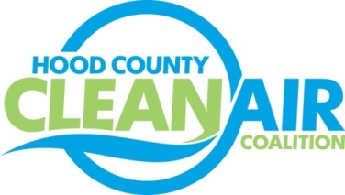
Meeting: Wednesday, July 6, 2016
Neely House
304 East Rucker Street, Granbury, Texas 76048
8:30-10:00 a.m.

Agenda

- Call Meeting to Order
- EPA Updates – Randy Pitre
- Regional Updates – Michelle McKenzie
  - Free Solar Webinars (Information at http://www.gosolartexas.org/events)
Webinars Friday - July 8 – Community Solar, Wednesday - July 27- Leveraging Underutilized Land
  - Upcoming Trainings (Information at http://www.dfwcleancities.org/cals/default.asp)
    - Propane Subcommittee Meeting July 18
    - CNG Fuel System Inspector Training August 2-3
  - Redesignation Substitute for 1 Hour Ozone and 1997 8 Hour Ozone NAAQS for DFW
  - TCEQ SIP Revision for 2008 Ozone Standard
  - Regional Air Quality Update
  - Air Quality Funding Opportunities for Vehicles
- Local Updates – Michelle McKenzie
  - Review of May and June Meeting Summary
  - Review of Projects
    - Monthly Budget Review for April and May
    - Status of Projects FY 16/17
  - Reports
    - June Ozone Update
    - DFW Clean Cities Meeting
  - 2016 Hood County Update for Ozone Advance
  - Annual Minutes filing for HCCAC
6.) Discussion
7.) Adjourn

